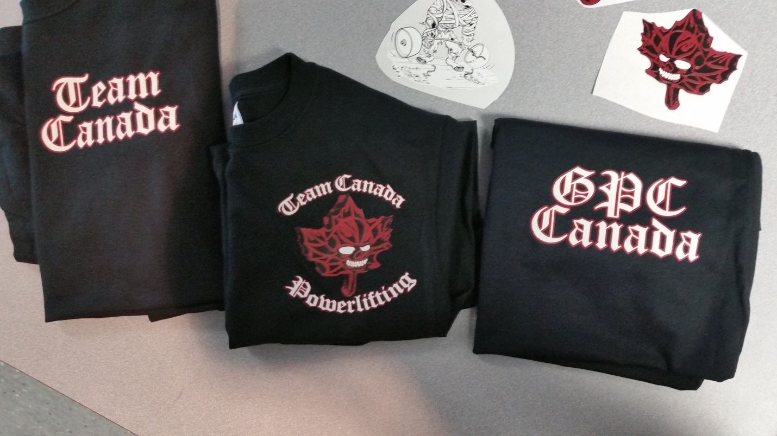
GPC Canada
Team Canada PL w/leaf (large and small size available)

Team Canada

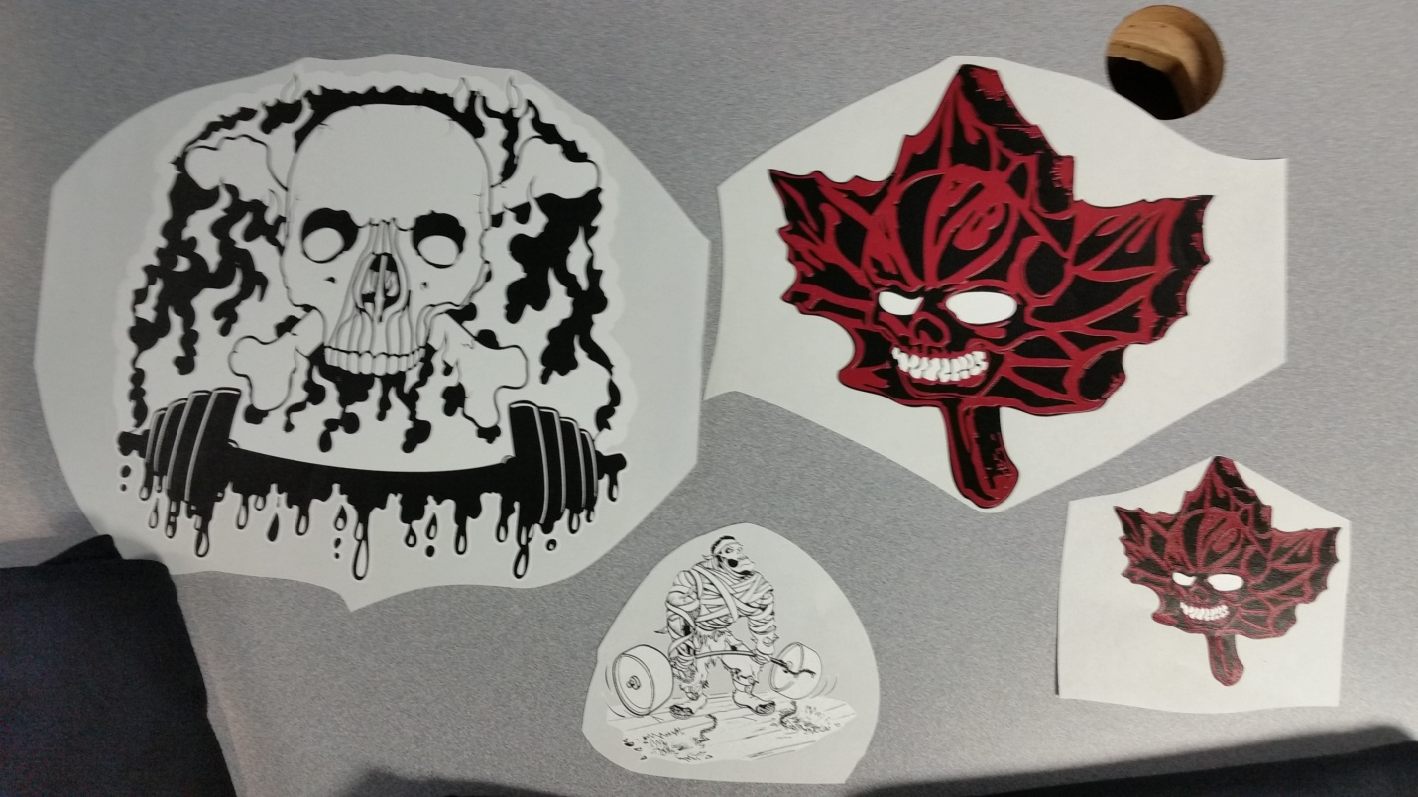
Independent small leaf
Independent large leaf
Zombie deadlift
Skull/barbell

Available for purchase
To inquire or order please email: michellesenger@hotmail.com

INCLUDE:
type of apparel
size
logo(s)
-3 or more logos subject to additional cost
Also available are Independent Powerlifting logos
Prices depend on size

Men’s t-shirts $25-30
Men’s long sleeve t-shirts $30-35
Hoodies $60-85
Sweat shirts $30-35
Yoga pants $60
Women’s tank tops $25

